Project Design Phase
Solution Architecture
Date | 01/10/2026
Team ID | SWTID-2026-1051
Project Name | Implement Client Script & UI Policy (Incident)
Maximum Marks | 4 Marks

Solution Architecture:
Solution architecture bridges the project problem and the technology implementation. For this project, the architecture defines the Incident user interface, UI Policy controls, Client Scripts, ServiceNow Incident data and validation feedback flow.
- Find the appropriate ServiceNow configuration to solve the Incident data-entry problem.
- Describe the structure and behaviour of the Incident form and list controls.
- Define the UI Policy and Client Script features used by the solution.
- Provide a clear implementation flow that can be configured, tested and maintained in ServiceNow.
Solution Architecture Diagram:
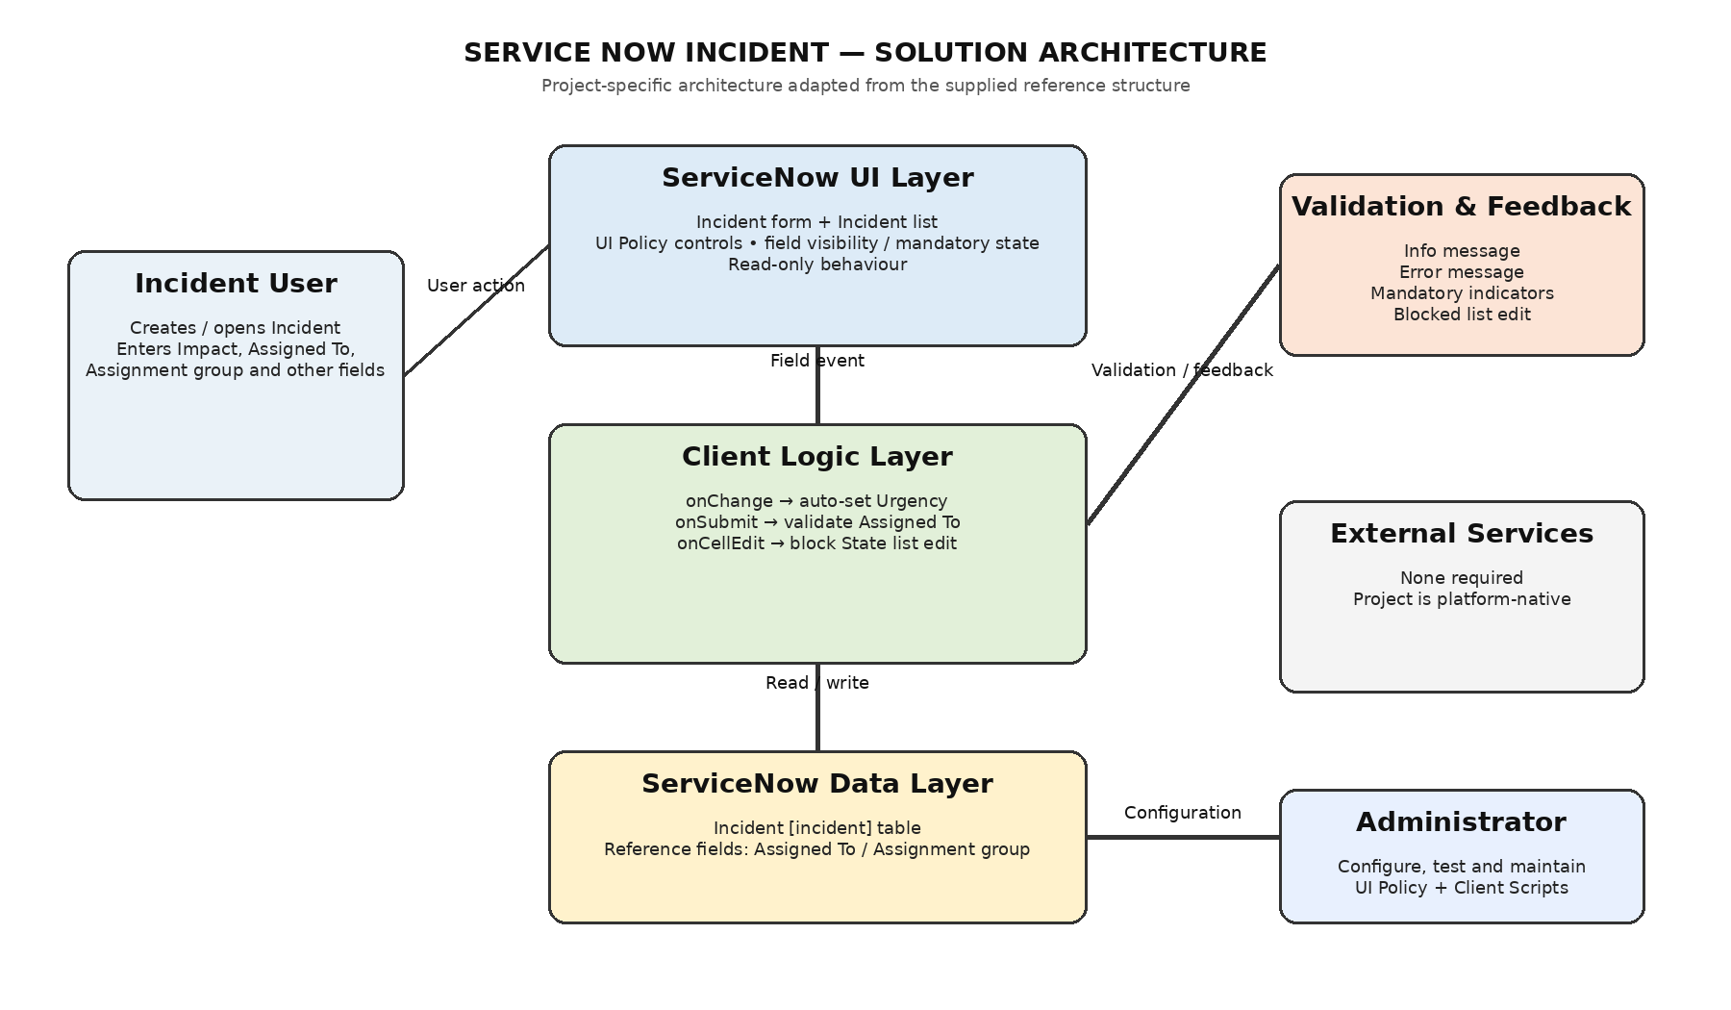
Figure 1: ServiceNow Incident solution architecture and control flow

